From 2022 booking for Hertfordshire Scouts Peak Assault (HPA) has moved on-line using the County’s platform.
These notes are intended to guide you through the booking process. If you have any queries about your booking please contact the County Support Centre . If you have a query about the event please email the Registrar (hpa@hertfordshirescouts.org.uk)
- Download the General Information document for details of the event, fees and the requirements for entry.
- Follow the link on the HPA web page to the booking portal. Here you can choose and book the various elements of your entry.
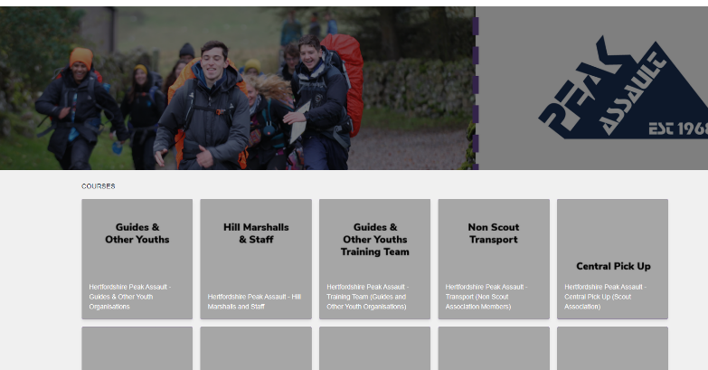
An entry is comprised of several elements which are added to the shopping basket separately:
A) The team and supporters
B) Transport
C) Catering
Please ensure that you have booked the right number of each – particularly the transport.
- Firstly choose what sort of team you are entering. i.e. Explorer, Network, Senior, Guide/Other organisation.
- Enter the number of people in each category. e.g. You are entering 2 teams of Explorers (6 in each), one is a training team and you have one other adult supporter. You enter 1 Adult Supporter, 12 Explorer and 1 Walking Leader.
- Select the date. (Only one date is available)
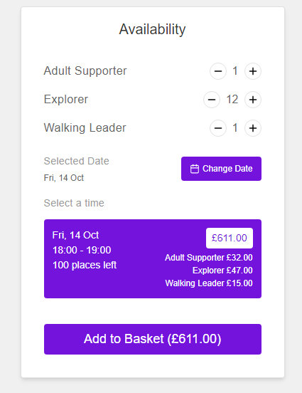
- Then ‘Add to Basket’ and ‘Continue Shopping’
- If your entry includes Network or Senior teams then add those to the Basket in the same way.
- Click to go back to the list of elements and add the transport. Depending on the make-up of your entry you may need to select more than one type of the following transport options. Add to the basket. Make sure the number of ‘seats’ you enter matches the number of competitor and supporters.
Transport: This is for Scout Association members travelling from Hertfordshire by coach
Non Scout Transport: This is for Non Scout Association members travelling from Hertfordshire by coach.
Central Pick Up: This is for Scout Association members who are travelling from the Central Pick Up Point.
Non Scouts Central Pick Up: This is for Non Scout Association members who are travelling from the Central Pick Up Point.
For individuals or teams who live outside Hertfordshire and where using the Central Pickup is not a practical option please see 4.2.2 in the General Information document.
- Next add the number of any adults taking the catering package. Click on ‘Catering’ and add the number.
- When you have selected all the options for your entry either click on ‘Go to Checkout’ or click on the basket icon at the top of the browser window and then ‘Go to Checkout’
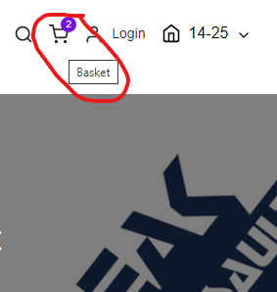
- Complete the Contact Details and follow the instructions to complete the booking.
- Download the appropriate Team List for you team(s) from the Peak Assault web site. There are two, and Explorer Team List and a Network/Senior Team List. These are Excel files. If you are pasting information into them, only paste the data (don’t include formatting or formulas). Please complete, save and email to the Registrar.

